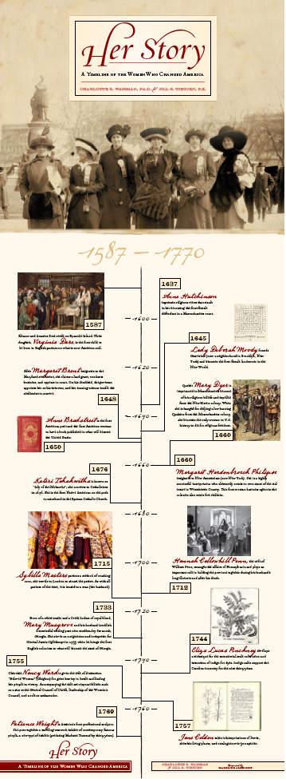
One of up to 20 vertical banner stands that accompany Charlotte Waisman and Jill Tietjen on their speaking engagements. These displays vividly depict the accomplishments of women from Her Story: A Timeline of the Women Who Changed America.

