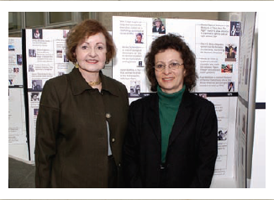

Speaker Introductions

Charlotte S. Waisman, Ph.D. and Jill S. Tietjen, P.E.

Authors of Her Story: A Timeline of the Women Who Changed America

Charlotte S. Waisman, PhD, is a nationally known champion for women. Over the last twenty-five years, she has advocated for women as a professor, political activist, keynote speaker, and expert witness. As a corporate leader, executive coach and facilitator, Waisman coauthored several books, including 50 Activities for Developing Leaders and The Leadership Training Activity Book. She is currently a vice president with a worldwide consulting company specializing in large-scale leadership, gender, and culture changes. Waisman is also director of human resources for the Women’sVision Foundation, through which she speaks extensively across the country and conducts leadership workshops.

Jill S. Tietjen, PE, is an author, national speaker, and an electrical engineer. Her published books include the Setting the Record Straight series, which explores the history of women in accounting, engineering, and professional achievement. Tietjen is one of the top historians in the country on scientific and technical women. In addition, she works to nominate women of achievement to the National Women’s Hall of Fame. She is the president and CEO of Technically Speaking, a national consulting company specializing in improving opportunities for women and girls to have more career options in technology. Tietjen is also a frequent keynote speaker at engineering, science, and women’s conferences. She has been inducted into the Colorado Women’s Hall of Fame.

