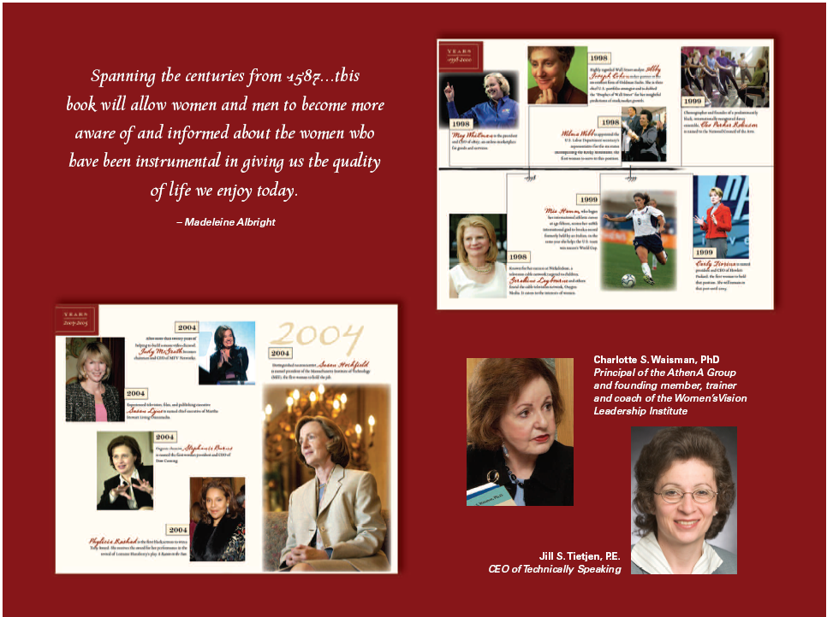

[Name of the Organization]
Invites You to [EVENT]
Featuring


A Timeline of the Women Who Changed America
By Co-authors Charlotte S. Waisman and Jill S. Tietjen

[DATE]
[TIME]
[FOOD DESCRIPTION]
[LOCATION]

[RSVP information]
[Sponsor’s name and logo]
[Sponsor’s name and logo]

