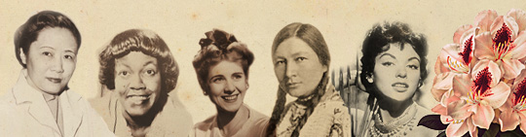
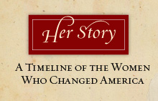

Harriet Beecher Stowe

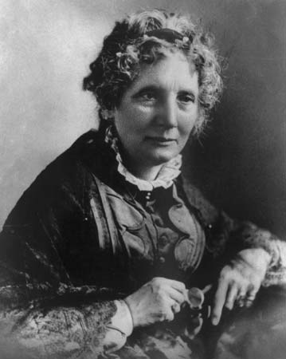
Abolitionist and author of best-selling book, Uncle Tom’s Cabin which shocked the country with its exposé of the extreme conditions of slavery.
YOUR ORGANIZATION’S NAME HERE

